SOLA-1116-Uplift forking page for single or joint account selection:

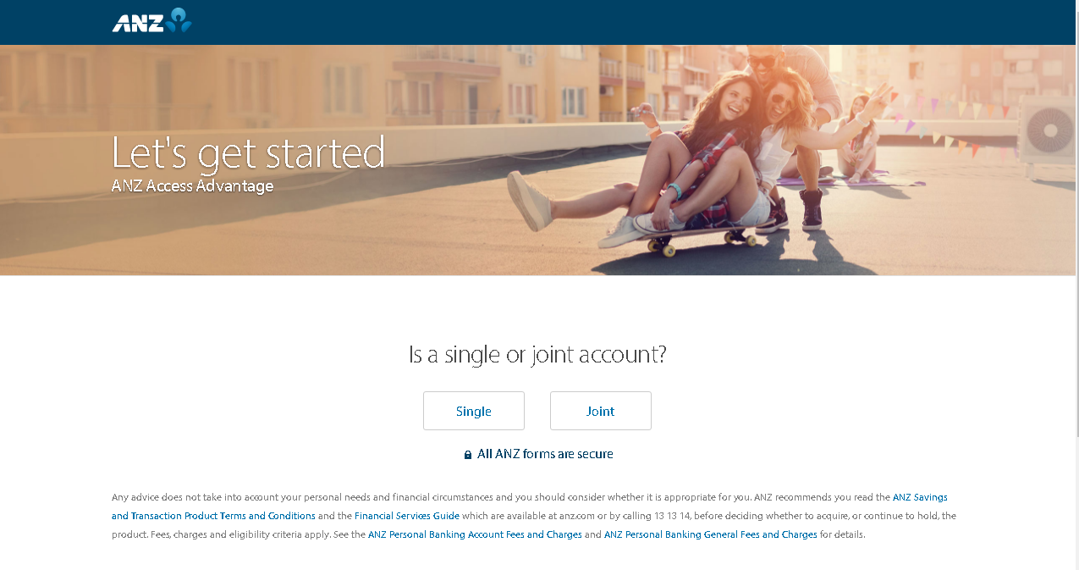

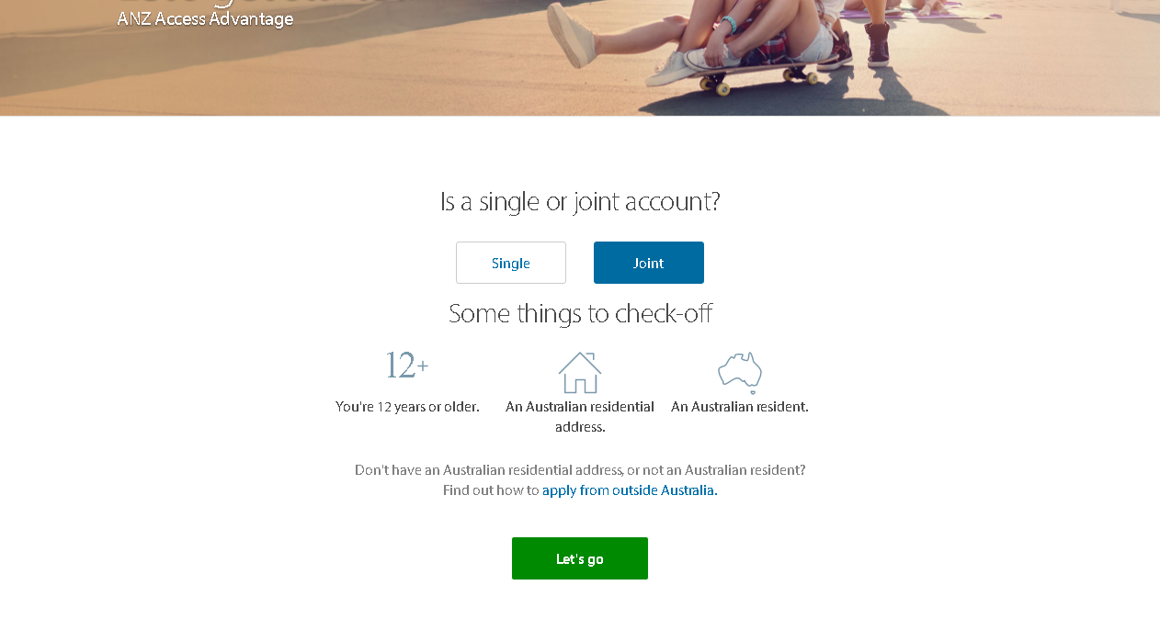

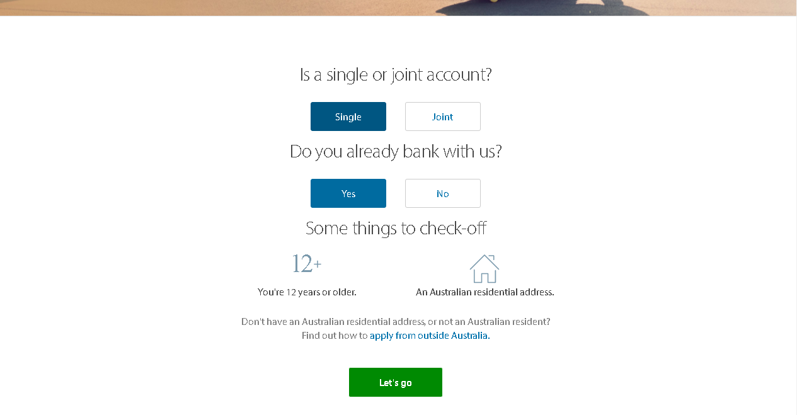

SOLA-1112-Term value to be hard coded as 12- CIM request fabrication to update CAP system with Progress Saver goal amount:

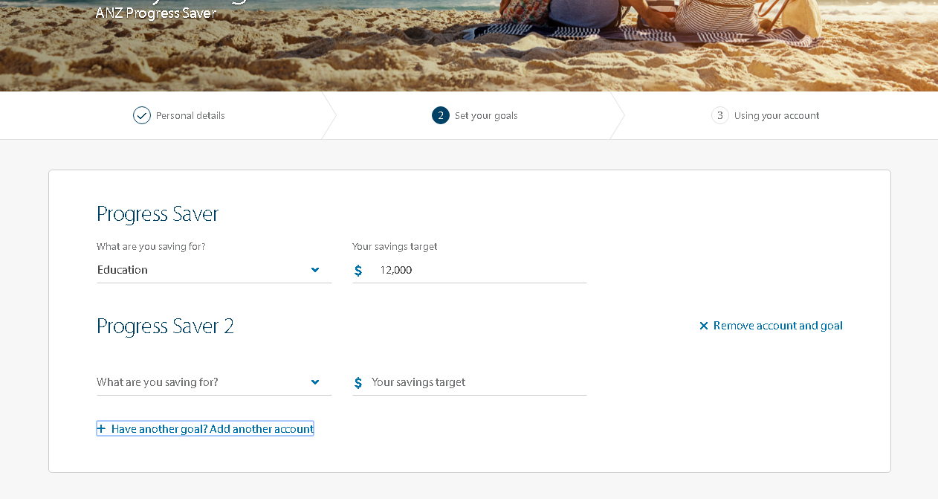

SOLA-1103-CRS Section - Expand of 'i' (Information section) to be independent of individual country addition:

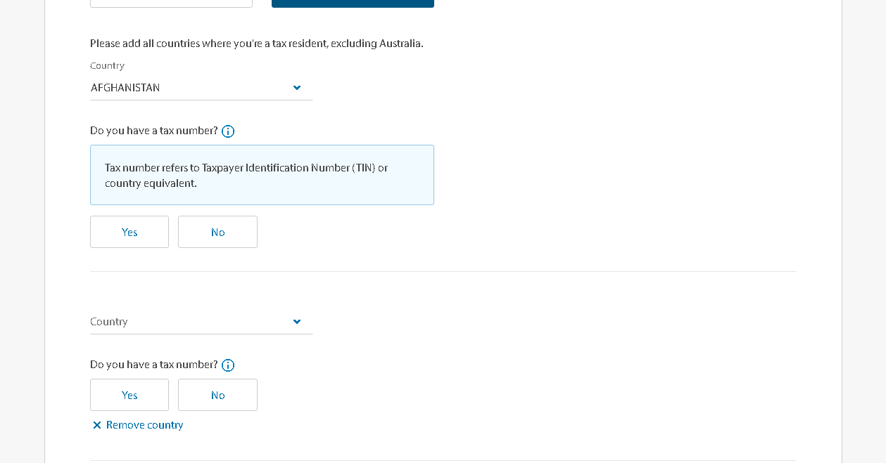

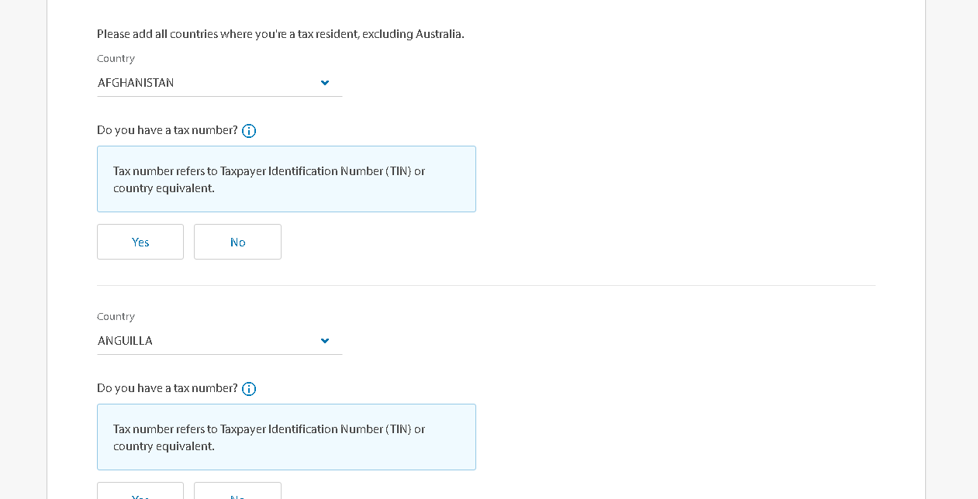

SOLA-1067-UI Uplift - Alignment of ANZ Logo and header module:

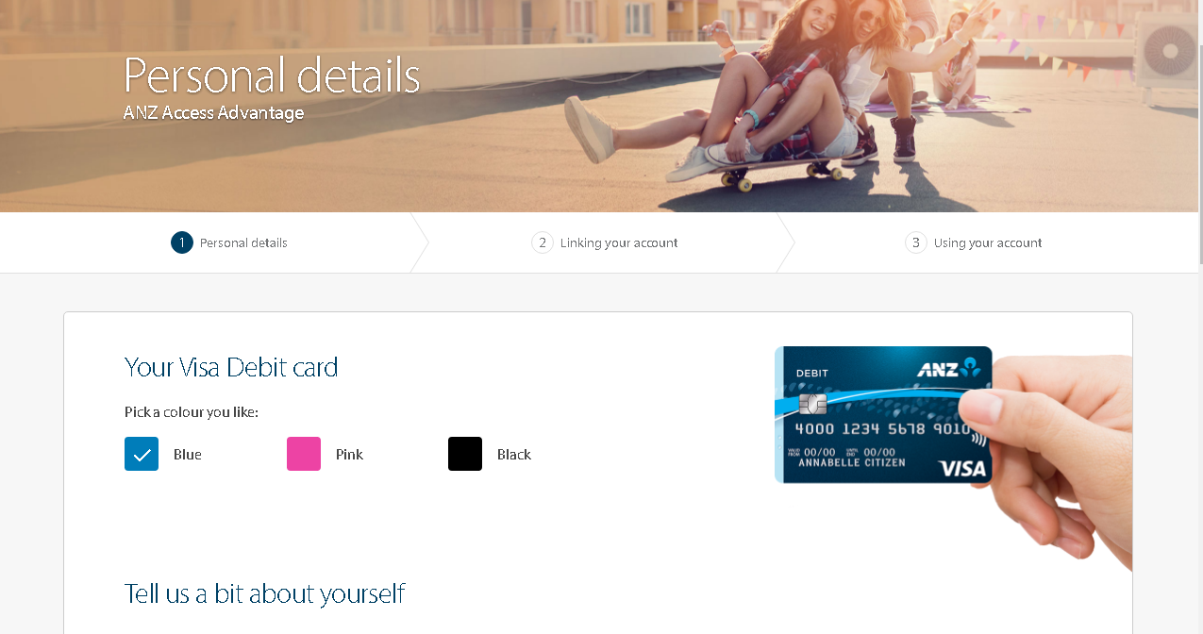

SOLA-1064-New link on forking page for customers with International Address:

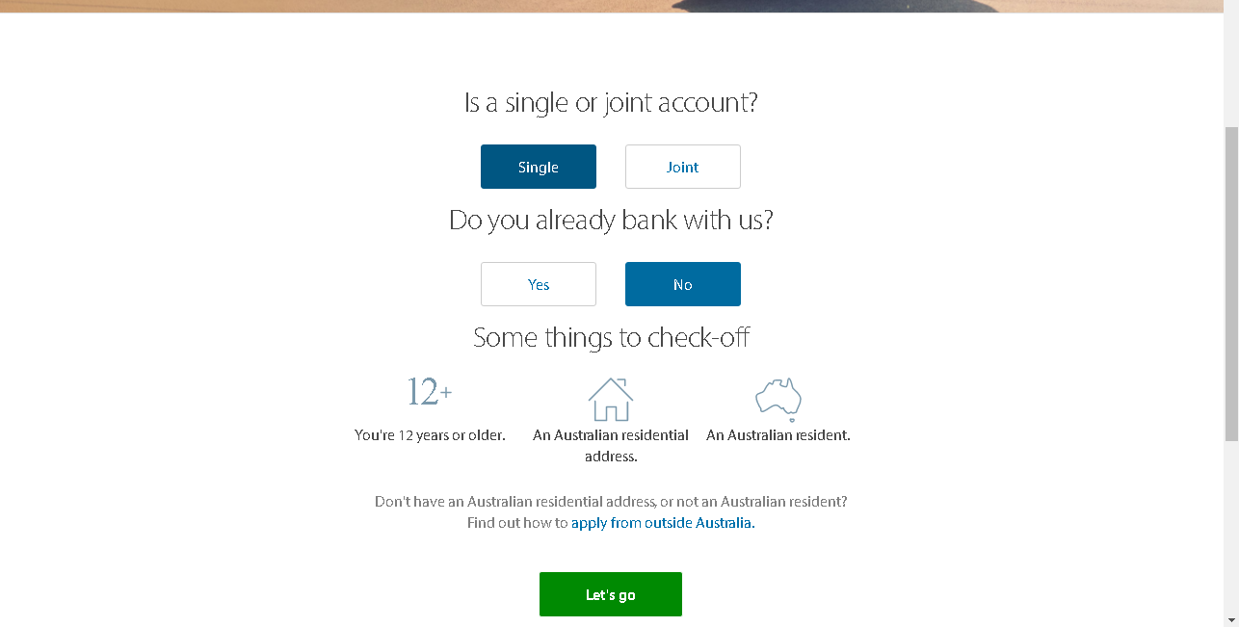

SOLA-1087-Centering Responsive display:

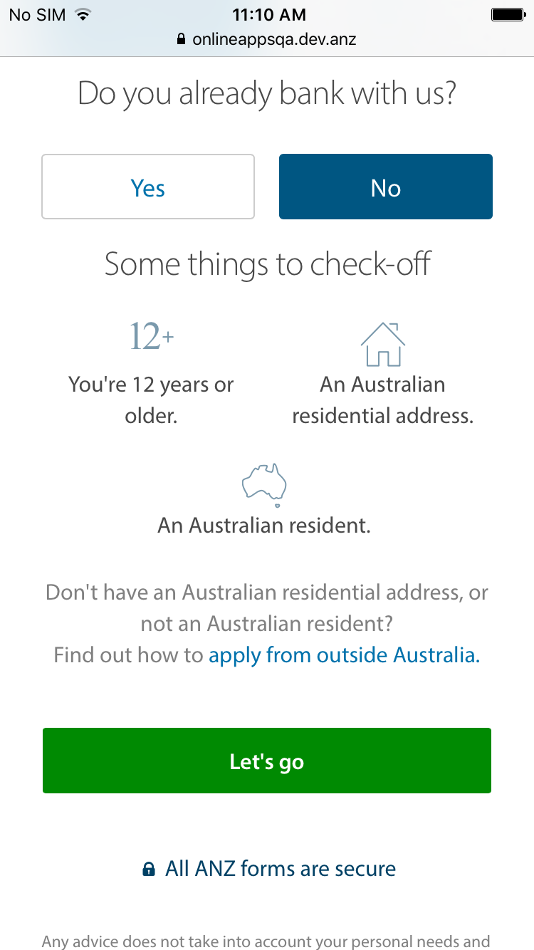

SOLA-1024-UI Uplift - Removal of icons from section headings for NTB customers:

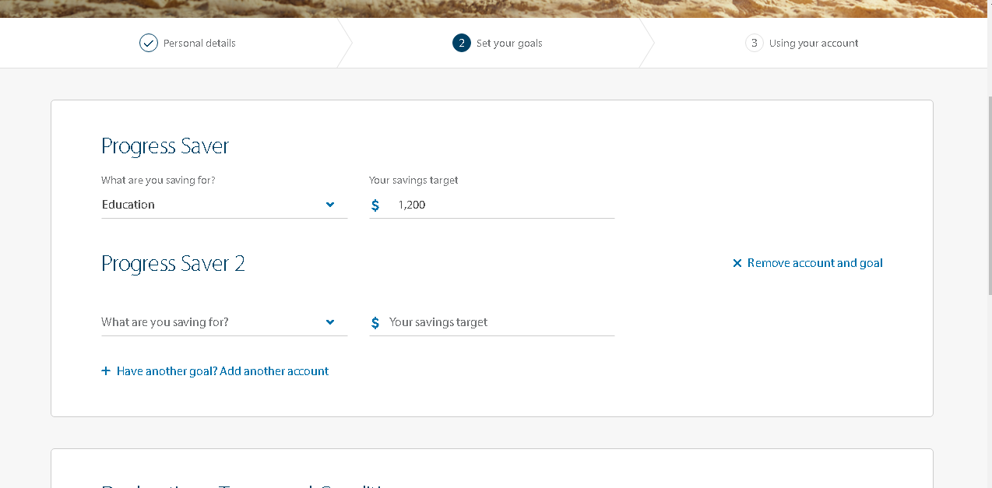

SOLA-998-Update to Spinner Text:

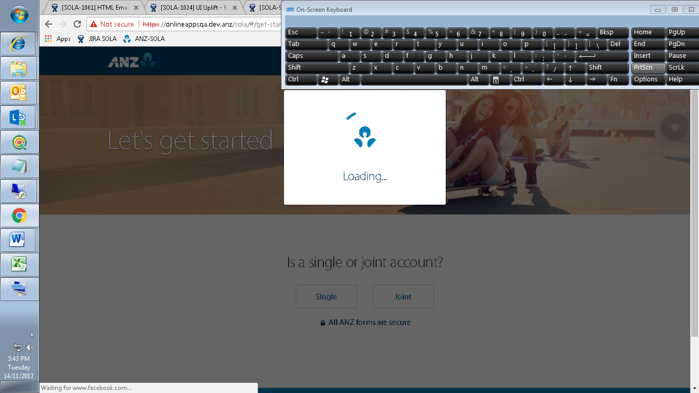

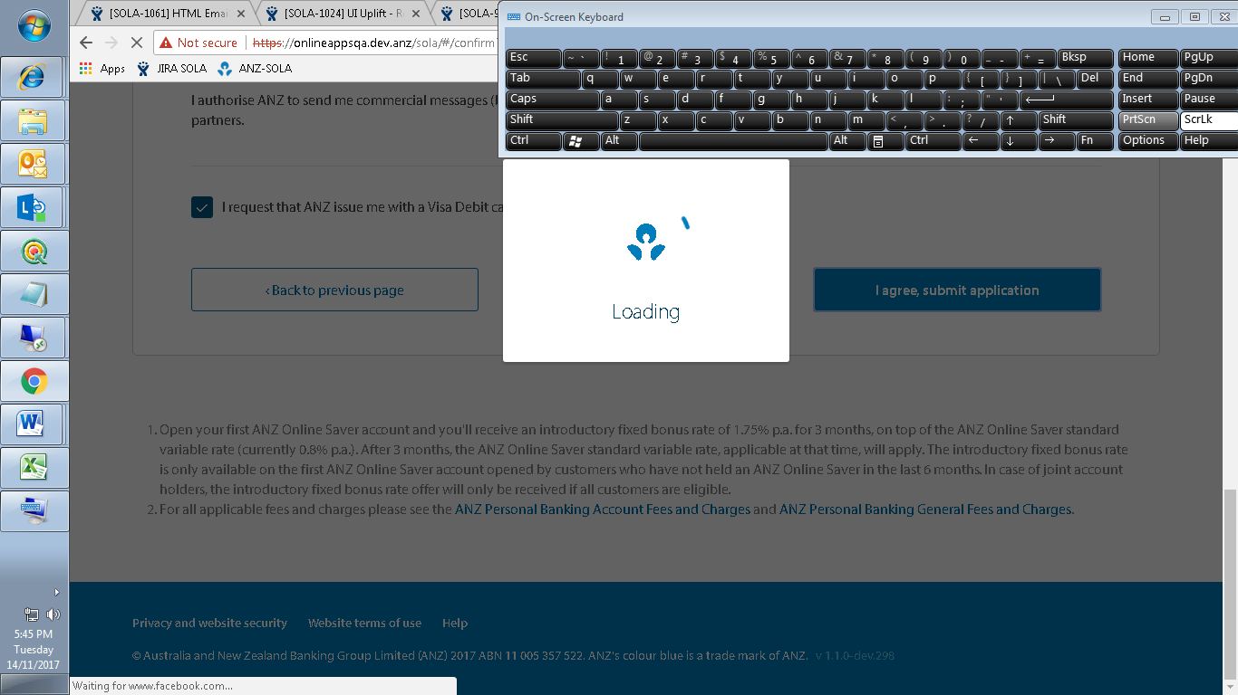

SOLA-980-Uplift CRS design: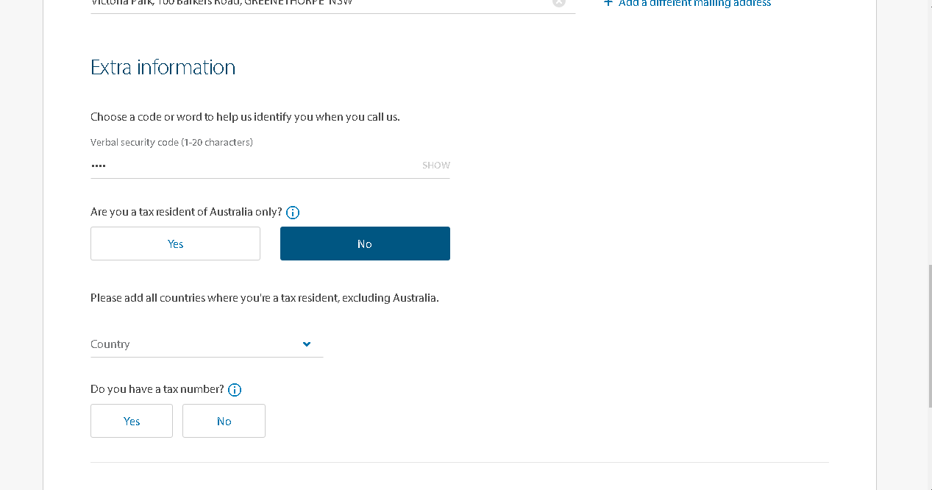

SOLA-969-Forking Page Uplift for quick log-into IB option for Authenticated Customers:

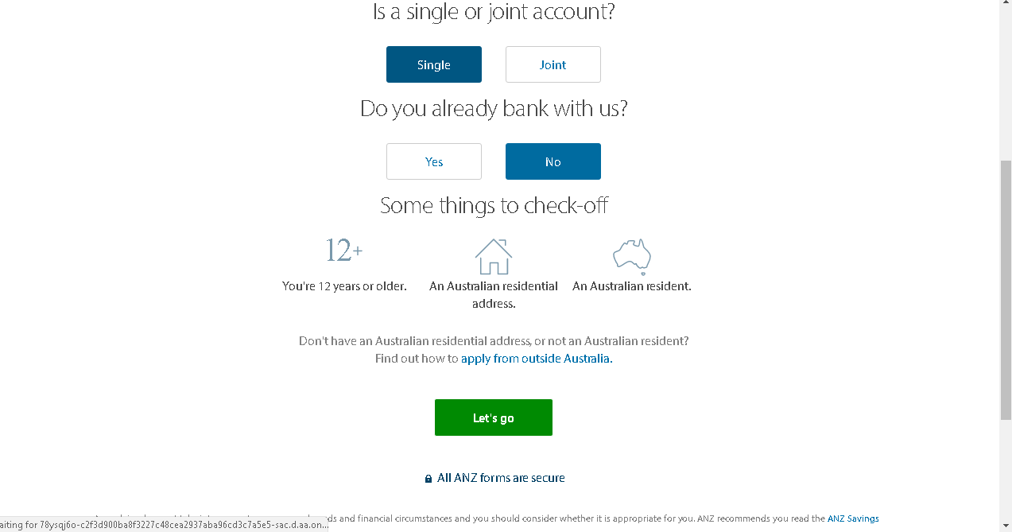

SOLA-967-Uplift copy - Dynamic text for declaration checkbox label:

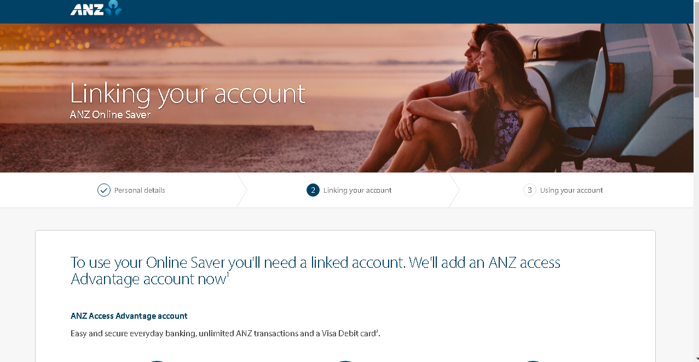

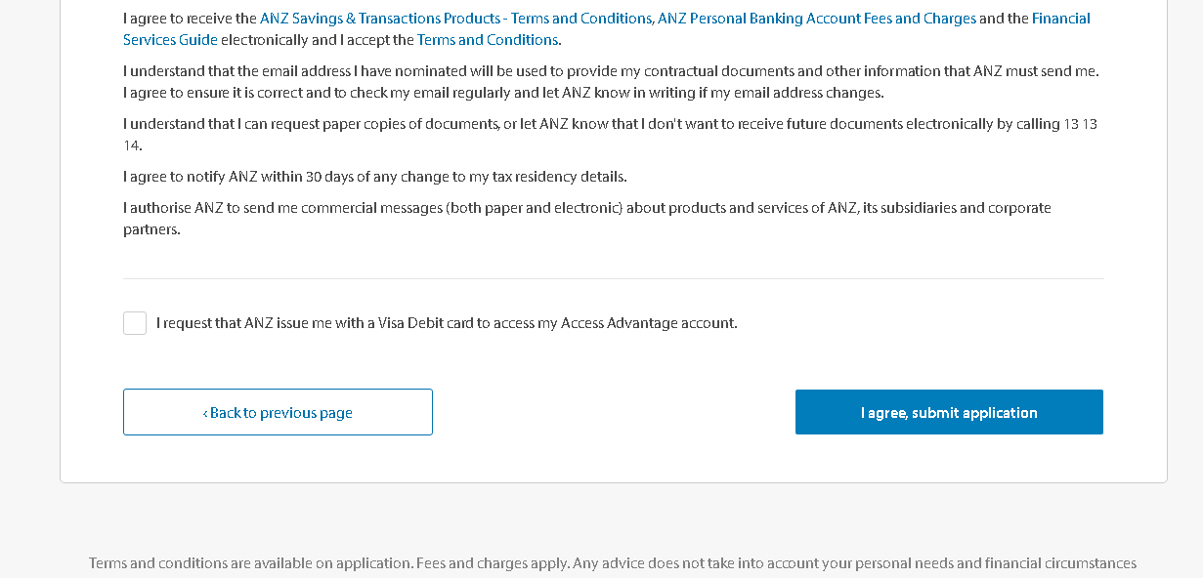

SOLA-875-Update UI to display new images for Visa Debit Card designs:

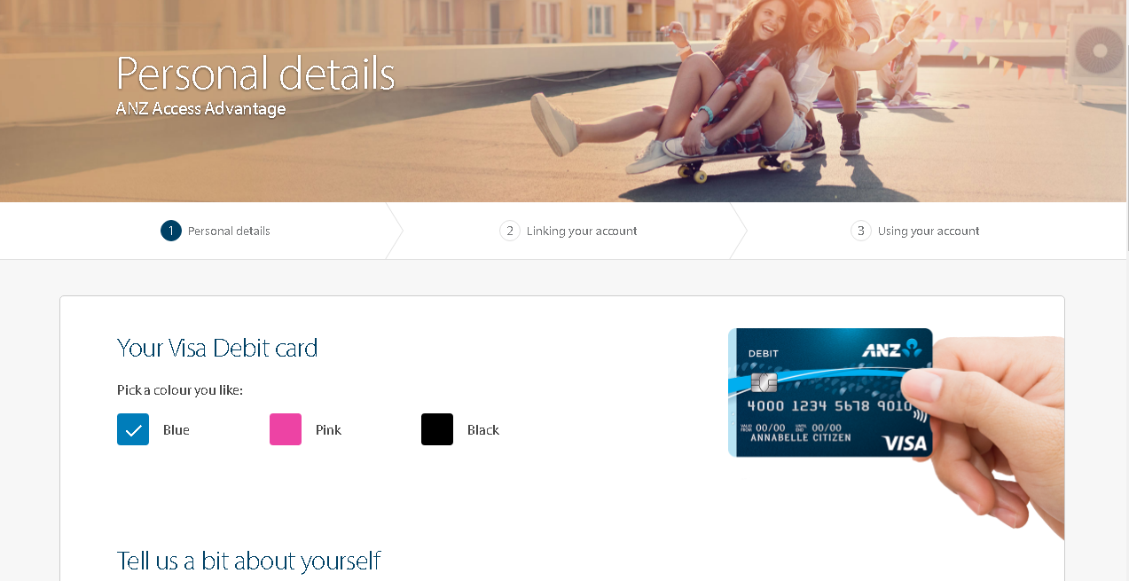

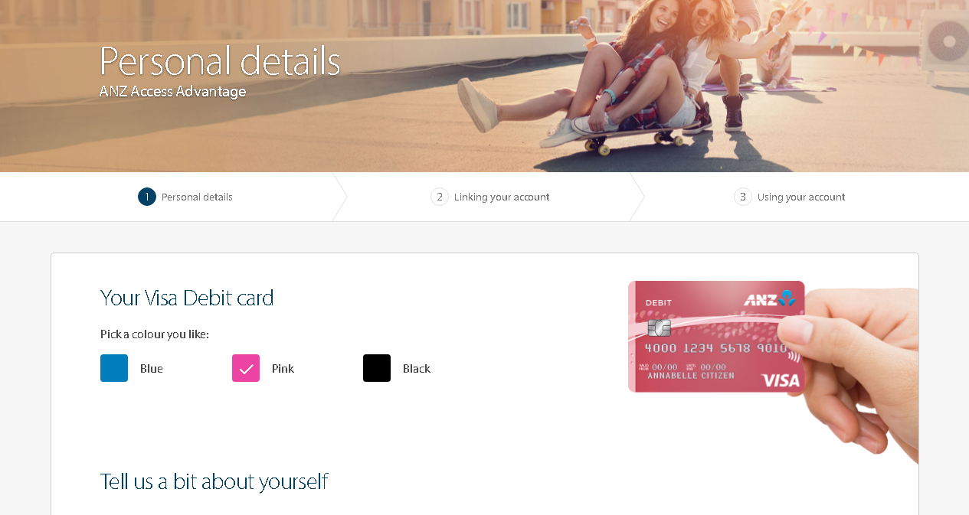

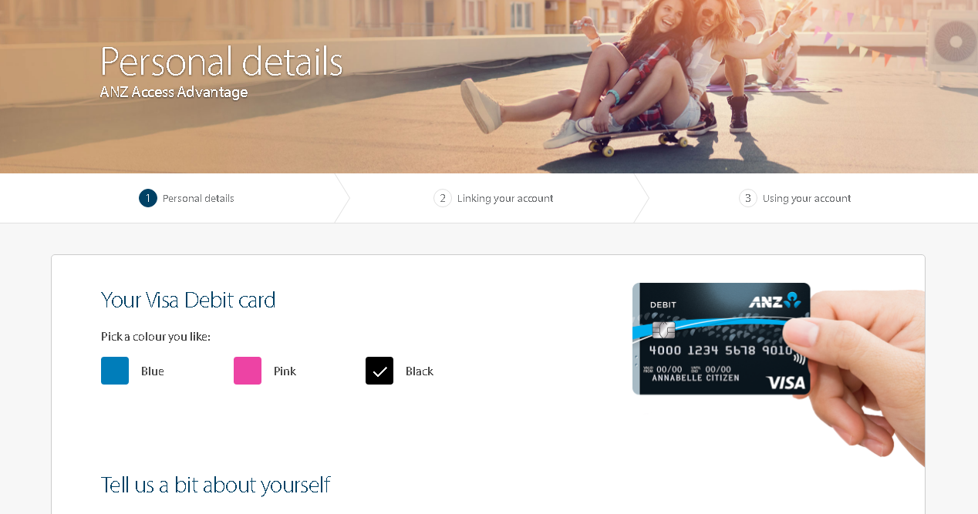

SOLA-286-Live Chat:

